u-logo-letterhead-u.wmfu-logo-letterhead-type-line.wmf

**EDUCATIONAL OUTREACH PROGRAMS**

**Engineering and Technology (E&T)**

**Overview**

The College of Engineering (CoE) will be embarking on setting up a series of offerings for the professional community through a variety of short courses and classes leading to Certificate Programs. These courses will target working professionals (with at least a BS degree) and range from refresher classes to advanced technology offerings. A catalog of (CoE UM designed) focused classes and educational programs that merge innovative engineering practices with the latest technology and training to develop the next generation of workforce professionals. The courses envisioned for the program will require and use the full range of university faculty knowledge, skills, and expertise while providing students and professionals pathways to advancing their careers in Engineering and Technology (E&T). The E&T Program will incorporate the [CoE Thrust Areas](https://www.coe.miami.edu/research/strategic-thrusts/index.html) while serving as a standard of excellence and achievement for students and the University of Miami. The objective of the E&T Program is to create a workforce pipeline of talented and qualified professionals that will meet expanding industry needs.

Different modalities will be explored – in-person, online and hybrid. For the online and hybrid offerings, a partnership with the Division of Continuing and International Education (DCIE) will be developed

Engineering@Miami (through CoE) will leverage Education, Innovation, and Industry Collaborations to achieve our objectives. Refreshers on current leading industry practices will incorporate the synergistic relationships between law, medical, business, engineering, and policy. The generation of technology adept students looking to advance their careers or pivot to a more fulfilling career will benefit from UM mentors, industry partner networks, and the standards to which we train. Our E-CAP program will also be a conduit to support such programs.

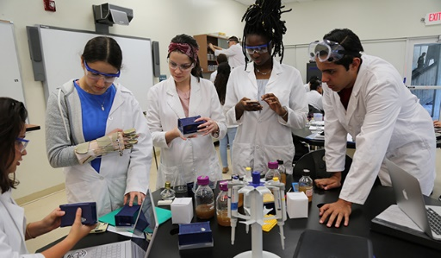

The following is a list of envisioned programs.

**Envisioned Phase I Certificate Pathways:**

() Computational & Data Sciences () Energy & Environmental Sustainability  
() Aerosol Science and Technology () Construction Engineering & Management   
() Executive Education and Networking () SF Water Management Training   
() Advance Materials and Structures () Community Disaster Resilience

**Advanced Courses for Envisioned Phase II Certificate Pathways:**

() Advanced Aerosol Science and Technology () Energy Management   
() Socio-Economic Adaptive Engineering () Coastal Law and Policy   
() Public Health in the Built Environment () Green/Grey Infrastructure

**Business Model for Revenue Sharing: Incentivizing CoE Faculty**

The Office of the Dean, College of Engineering, will finalize agreements with the faculty offering the non-credit class for the professional community. Each faculty member will provide a budget for the offering of the class, which will clearly articulate expenses and revenue. If the class is being offered in conjunction with DCIE (online or hybrid versions), the faculty member should review the MOU in place to understand overall expenses to be incurred.

The faculty member will receive 40% of the net revenue (to their discretionary account, with a portion to be taken as salary consistent with the compensation guidelines), the department will receive 20% and the College of Engineering will receive the remaining 40%.

A signed document (by the course instructor, Department Chair and Dean) will clearly describe the agreement for the class, including revenue distribution.

The coordinator of this program is Dr. Esber Andiroglu [e.andiroglu@miami.edu](mailto:e.andiroglu@miami.edu)